Workplace Safety:

<https://datawrapper.dwcdn.net/BjvA4/2/>

Food safety:

<https://datawrapper.dwcdn.net/8mo8q/1/>

King Carrot: Across the United States, Carrots Reign Supreme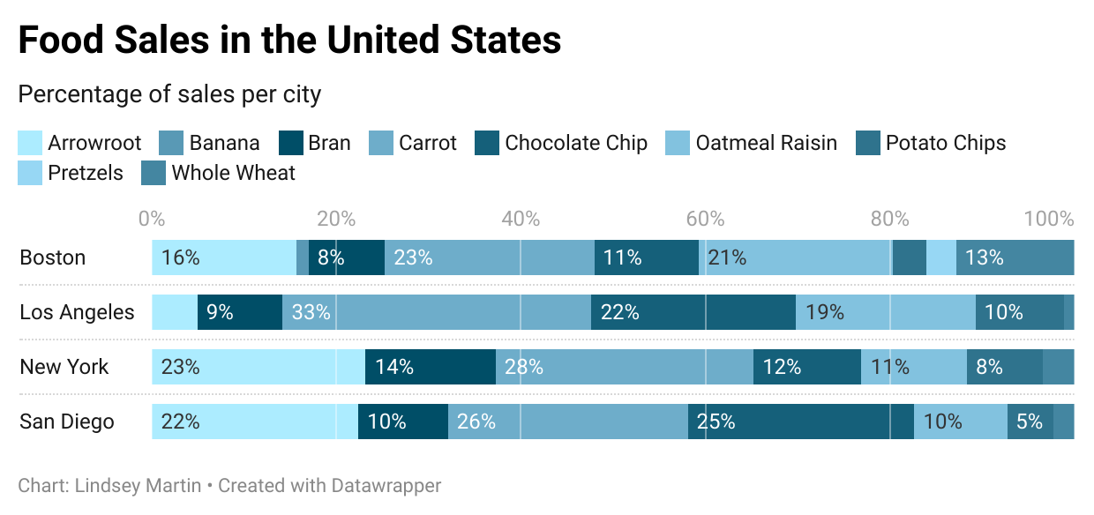

A recent study has revealed American’s steadfast preference for carrots, making up at least a quarter of food sales in four of the major cities in the United States.

This news comes alongside increasing concern nationwide that fresh fruits and vegetables are becoming difficult to access, and are often passed over by hungry consumers looking for a quick and filling meal.

These findings dispel many notions of our eating habits in the United States. The beloved potato chip, which the public has accepted as being “impossible to have just one,” comes last in food sales in these four cities, topping out at 10% of food sales in Los Angeles, and barely creeping above 5% across the other major cities. Similarly, pretzels, another widely popular snack food, only make the list in Boston, with just 3.3% of food sales.

Carrots, however, remain strong across the board. What is unclear in the data is what form these carrots are purchased in. A common ingredient in baby food, it is quite possible that the bulk of these sales are not being consumed by adults. Certainly, food sales cannot always be translated into food consumption habits, as many a carrot has been neglected on a potluck vegetable platter, only to end up in another data set documenting food waste.

Still, the medical community is sure to take note of these findings to track who is eating carrots. With one serving providing 75% of an adult’s daily requirement of vitamin A, carrots are critical for eye health as one ages. This has taken on increased importance as society becomes more reliant on screens, putting added strain on our eyes.

While it is still unclear who is consuming this large amount of carrots, it indicates a positive trend across the United States as health experts look to incorporate more fresh fruits and vegetables into the American diet.